Solar Lamp electrical system

# Project description:

The following system is a context diagram for a Solar street lamp’s electrical system. This system is a concept design at present and will be elaborated on if the concept is approved for prototyping.

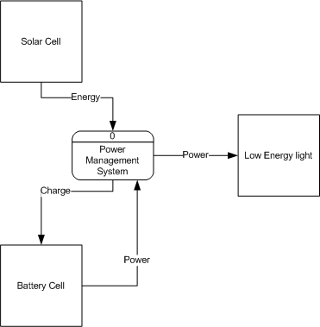

# System description:

The solar lamp will charge the battery throughout the day and when the ambient light outside is low enough to be considered night, the lamp will automatically switch on until either the ambient light is high enough to be considered day or the battery is drained beyond its available power supply.  
Using light detection the system will be completely autonomous and require little to no maintenance.

Regarding specifications the lamp will require the following main components:

* Solar Cell of approximately 100x100cm2
* 12V or 24V Battery at approximately 10Ah to 20Ah
* Microcontroller
* Power management circuit
* 40W – 70W LED light bulb

# System operation:

The Lamp will operate in the following manner:

1. Firstly the solar cell will charge supply power to the power management system.
2. The power management system will then charge the 12/24V battery for the first 2 – 3 days after installation until the appropriate level of charge is on the battery terminals.
3. Once the appropriate charge is acquired the power management system will monitor the ambient light using the microcontroller with relevant sensors.
4. If the ambient light conditions are ideal, the power management circuit will be triggered by the microcontroller to turn on the light bulb.
5. If the conditions are no longer ideal, the lamp will be switched off and charging will begin once more.